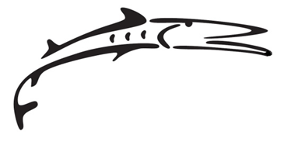
Parent Agreement Form
FACILITY SUPERVISION POLICY
Green YMCA Barracudas
Barracudas Facility Supervision Policy

ALL SWIMMERS UNDER THE AGE OF 11 MUST HAVE A PARENT OR GUARDIAN IN THE FACILITY WITH THEM AT ALL TIMES. Parents who do not remain in the pool area during the entire practice must notify their swimmer of where they will be within the building so the child can either locate them or can notify one of the YMCA staff members of their parent's location in case they are needed.

Please note that coaches are not permitted to take swimmers to the restroom. Coaches also will not refuse a child who truly needs to use the restroom. Therefore, if you are not on the deck to assist them, your swimmer will be permitted to enter either the rest room or the family changing rooms alone as needed. Coaches cannot leave the area to locate parents/guardians when a swimmer needs to use the restroom. It is highly recommended that if you do not allow your child to enter the rest rooms or family changing room alone, you should remain on deck; or in the lobby positioned where you can see them (if you trust that they will be responsible enough to get your attention before entering the restroom).

Swimmer safety is our primary concern, but please remember that this is a competitive sports program, not a 'child watch' or a program where children are checked in and out. Please use caution and your knowledge of your child's maturity level to determine whether or not it is necessary for you to remain on the pool deck. But as previously stated, every swimmer under the age of 11 must have a responsible adult (parent/guardian/chaperone) remain at the YMCA facility while that child is at practice so they are not alone.

Parents are also responsible for their child’s locker room behavior, and while at this time, parents are not required to be present with each child in the locker room, should problems begin to arise in the changing and shower areas before or after practices, the facility reserves the right to require parent supervision during these times. If your child is under the age of 11, a parent/guardian/chaperone must be in the building with that child at all times.

Violation of these policies may result in individual restrictions or removal from the team. Swimmers with repeated behavior problems and other concerns may be required to have a parent/guardian/chaperone on deck during all practices. Please contact a coach immediately if you have a concern over any safety issue.

I agree that I have read, understand, and agree to the above team policies, rules and requirements:

Parent’s Name (printed)_______________________ Swimmer’s Name(s)___________________

Parent’s Signature_____________________________ Date_____________________________

